**POST TEST QUESTION**

1. Make a jQuery to change the html code below:

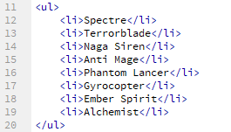

into a popup alret like the image below. dont forget to use document ready.

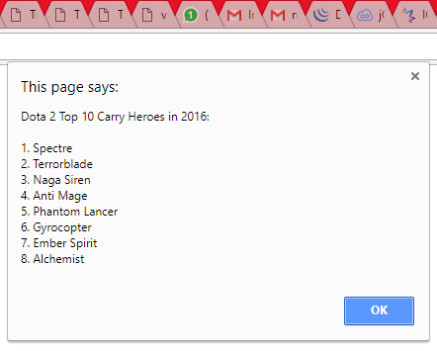

2. Make a jQuery function to change the HTML below: 

into a popup alert like this image below.

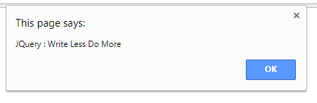

make a function with three variances, exactly as these requirements below. Dont forget to use document ready.

|  |  |  |
| --- | --- | --- |
|  | a. | using selector **TagName** |
| b. | using selector **ID** |
| c. | using selector **Class** |
| 3. | u | Make a jQuery function to change the HTML code below |

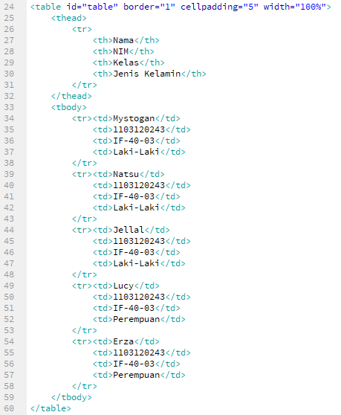

Into something like this image below with the requirements as follows : Note : Dont forget to use jQuery, **NOT CSS**

a. Row 1,3,5 to yellow color with function css()

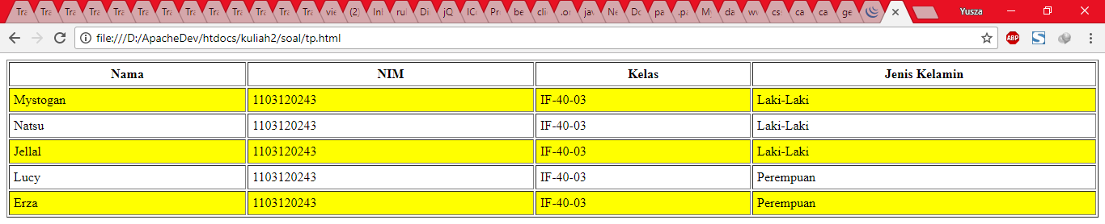

b. Row 3,4, into color blue with function **addClass()**

